Final Project Test Cases

GitHub: https://github.com/sell50/Network-Project

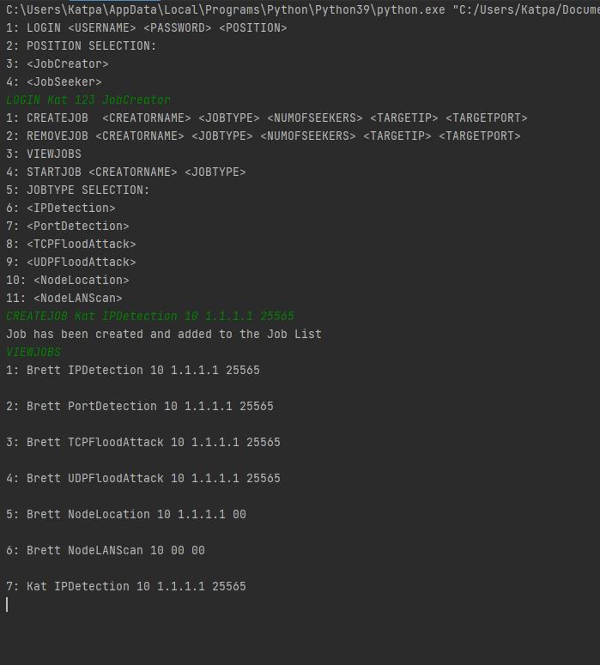

Figure 1: JobCreator Creating a job and then viewing the creating job

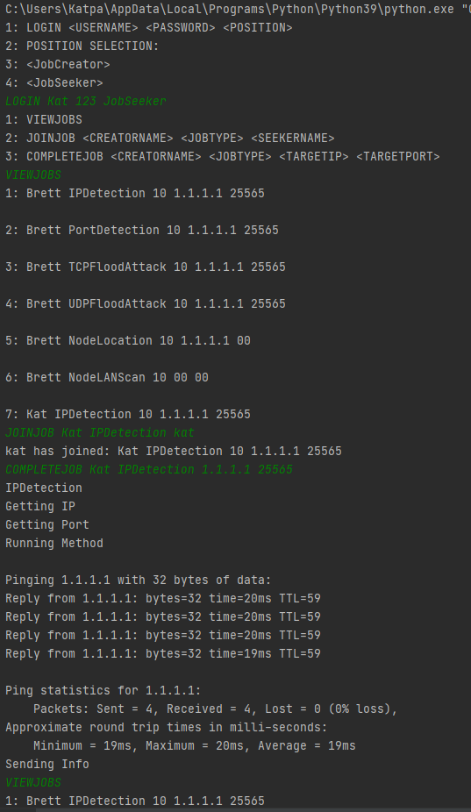

Figure 2: JobSeeker viewing job being created and completed it.

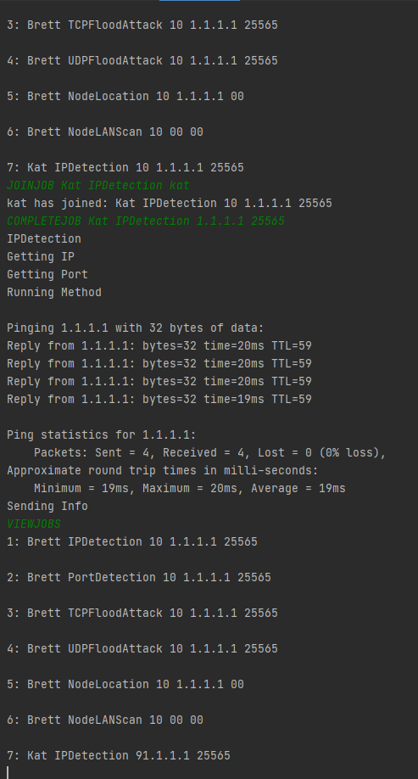

Figure 3: Continuation of JobSeeker for viewing jobs

Figure 4: Server showing connection with clients and job completion for JobCreator and JobSeeker

Figure 5: Node LAN Scan job

Figure 6: Node Location job

Figure 7: UDP Flood Attack job

Figure 8: TCP Flood Attack job

Figure 9: Port detection job

Figure 10: IP detection job

Figure 11: All Job outputs